QUESS CORP LIkIITED

HEAD OFFICE - 3/3/2,QUESS TOWER, SKY WALK AVENUE, 32/4, SERVICE ROAD, MUNESWARANAGAR, ROOPENA AGRAHARA, BOMMANAHALLI, BENGALURU, KARNATAKA,

w ia ui If 0 TO 0ETn Ee

 | 2002476889 |  | 331 4456857
 | ATHARV SUNIL SUPEKAR |  | 30.00
DATE OF JOINING | 21/03/2023 |  | 30.00
DESIGNATION | LOGISTICS EXECUTIVE |  | HDFC BANK
DEPUTED AT | REXEL INDIA PRIVATE LIMIT ED | BANK A/C NO | 501 0073377609 0
 |  | INSURANCE NO | BLR-N G-000 91 -001-00119 83-A
 |  | LOCATION
 | PY KRP00139920000349023  101929236802 |  | QS3016b62  0.00

BASIC  HOUSE RENT ALLOWANCE | 7,517.00 | PROVIDENT FUND  PROFESSIONAL TAX | 20000
OTHER ALLOWANCE | 3,531.00
STATUTORY_BONUS

BASIC  HOUSE RENT ALLOWANCE | 62185 | 30068 | 92253 | ACCOMODATION
OTHER ALLOWANCE | 33015 |  | 471 39 | OTHER
STATUTORY_BONUS | 9460 |  |  | PREVIOUS EMPLOYER INCOIvIE

DEDUCTION U/S 16 (PROFESSIONAL TAX) DEDUCTION U/S 16(IA) (STANDARD DEDUCTION) DEDUCTION UNDER CHAPTER VI-A
DEDUCTIONS U/S (10) AND (17) DEDUCTIONS UNDER CHAPTER VI (SEC 80)
EDUCATION CESS
75000 SECTION 87 RELIEF

TAX ON INCOME
TAX ON INCOME BLESS 87 RELIEF]
TAX RECOVERED
TAXABLE INCOME (NET SALARY - DEDUCTIONS)

NOTE: THIS IS A COMPUTER GENERATED DOCUMENT DOES NOT REQUIRE ANY SIGNATURE

FOR ANY OUERY, PLEASE REACH US @ 1800-572-3333 OR WRITE TO HELP@QUESSCORP.COM

248664

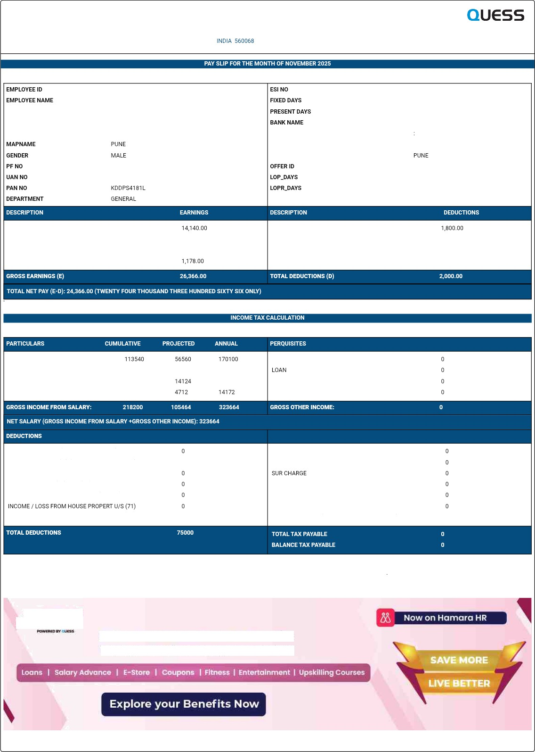


Quess introduces Homoro Benefits
Employee Benefits & Engagement Platform

FEB 3 2026 10:T3AM

